**Bank Loan Analysis Report using SQL Server Query Document**

**KPIs**

**Total Loan Applications:**

select count(id) as Total_Applications from Bank_Loan_Data

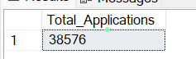

**MTD Loan Applications:**

select count(id) as MTD_Total_Applications from Bank_Loan_Data

where month(issue_date)= 12

# for December month



**PMTD Loan Applications:**

select count(id) as PMTD_Total_Applications from Bank_Loan_Data

where month(issue_date) = 11 # for November month



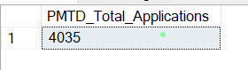



**Total_Funded_Amount =**

select SUM(LOAN_AMOUNT) AS Total_Funded_Amount from Bank_Loan_Data

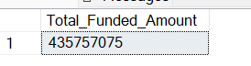

**MTD_ Total_Funded_Amount =**

select SUM(LOAN_AMOUNT) AS MTD_Total_Funded_Amount from Bank_Loan_Data

where month(issue_date) = 12 and year(issue_date) = 2021



**PMTD_Total_Funded_Amount =**

select SUM(LOAN_AMOUNT) AS PMTD_Total_Funded_Amount from Bank_Loan_Data

where month(issue_date) = 11 and year(issue_date) = 2021

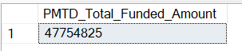

**Total_Amount_Recived =**



select SUM(Total_Payment) AS Total_Amount_Received from Bank_Loan_Data



**MTD_Total_Amount_Recived =**

select SUM(Total_Payment) AS MTD_Total_Amount_Received from Bank_Loan_Data

where month(issue_date) = 12 and year(issue_date) = 2021

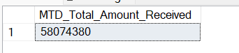

**PMTD_Total_Amount_Recived** =

select SUM(Total_Payment) AS PMTD_Total_Amount_Received from Bank_Loan_Data

where month(issue_date) = 11 and year(issue_date) = 2021

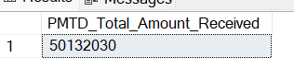

**Average_Intrest_Rate =**

select Avg(int_rate)*100 as Avg_Intrest_Rate from Bank_Loan_Data

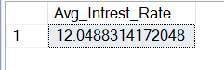

**MTD_Average_Intrest_Rate=**

select Avg(int_rate)*100 as MTD_Avg_Intrest_Rate from Bank_Loan_Data

where month(issue_date) = 12 and year(issue_date) = 2021

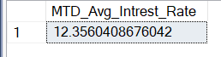

**PMTD_Total_Intrest_Rate =**

select Avg(int_rate)*100 as PMTD_Avg_Intrest_Rate from Bank_Loan_Data

where month(issue_date) = 11 and year(issue_date) = 2021

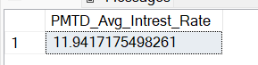

**Average Debt-to-Income Ratio (DTI):**

select Avg(dti)*100 as Avg_Debt_to_income_Ratio from Bank_Loan_Data

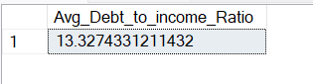

**MTD_Avg_Debt_to_Income_Ratio =**

select Avg(dti)*100 as MTD_Avg_Debt_to_income_Ratio from Bank_Loan_Data

where month(issue_date) = 12 and year(issue_date) = 2021

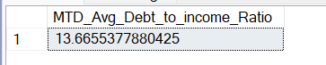

**PMTD_Avg_Debt_to_Income_Ratio =**

select Avg(dti)*100 as PMTD_Avg_Debt_to_income_Ratio from Bank_Loan_Data

where month(issue_date) = 11 and year(issue_date) = 2021

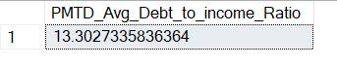

**Good Loan**

**Good_Loan_Percentage =**

select

(count(case when loan_status = 'Fully Paid' or Loan_Status = 'Current' then id end)*100)

/count(id) as Good_Loan_Percentage

from Bank_Loan_Data

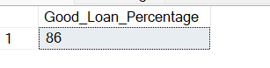

**Good_Loan_Applications =**

select

count(id) as Good_Loan_Applications from Bank_Loan_Data

where loan_status = 'Fully Paid' or Loan_Status = 'Current'

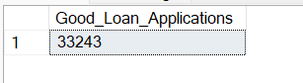

**Good_Loan_Funded_Amoount =**

select sum(loan_amount) as Good_Loan_Funded_Amount from Bank_Loan_Data

where loan_status = 'Fully Paid' or Loan_Status = 'Current'

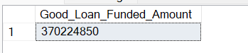

**Good_Loan_Total_Recived_Amount=**

select sum(total_payment) as GLTotal_Ampunt_Recieved from Bank_Loan_Data

where loan_status = 'Fully Paid' or Loan_Status = 'Current'

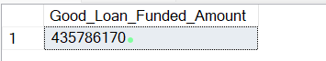

**BAD LOANS**

**Bad_Loan_Applications_Percen**t =

select

(count(case when loan_status = 'Charged Off' then id end)* 100)

/count(id) as Bad_Loan_Applications_Percent

from Bank_Loan_Data



**Bad_Loan_Apllications =**

select

count(id)as Bad_Loan_Applications from Bank_Loan_Data

where loan_status = 'Charged Off'

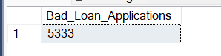

**Bad_Loan_Funded_Amount =**

select sum(loan_amount) as Bad_Loan_Funded_Amount from Bank_Loan_Data

where loan_status = 'Charged Off'

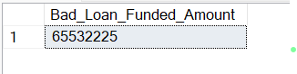

**Bad_Loan_Total_Recived =**

select sum(total_payment) as Bad_total_amount_Recived from Bank_Loan_Data

where loan_status = 'Charged Off'

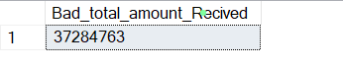

**Loan Status Veiw**

select loan_status,

count(id) as Total_Loan_Applications,

sum(loan_amount) as Total_Funded_Amount,

sum(total_payment) as Total_Amount_Recived,

avg(int_rate)*100 as avg_intrest_rate,

avg(dti)*100 as avg_dti_rate

from Bank_Loan_Data

group by loan_status;

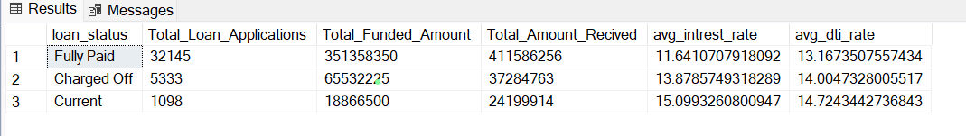

**MTD**

select loan_status,

sum(loan_amount) as MTD_Total_Funded_Amount,

sum(total_payment) as MTD_Total_Amount_Recived

from Bank_Loan_Data

group by loan_status;

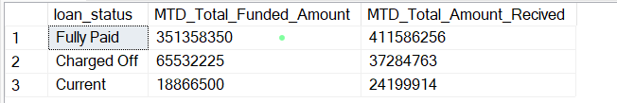

MONTH

SELECT month(issue_date) as Month_Number,

datename(month,issue_date) as Month_Name,

sum(loan_amount) as Total_Amount_Funded,

sum(total_payment) as Total_Amount_recived

from Bank_Loan_Data

group by month(issue_date),

datename(month,issue_date)

order by month(issue_date)

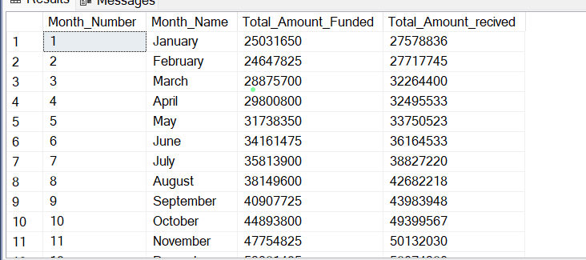

**Regional Analysis by State =**

select address_state as State,

sum(total_payment) as Total_Amount_Received,

Sum(loan_amount)as Total_Amount_Funded

from Bank_Loan_Data

group by address_state

order by address_state

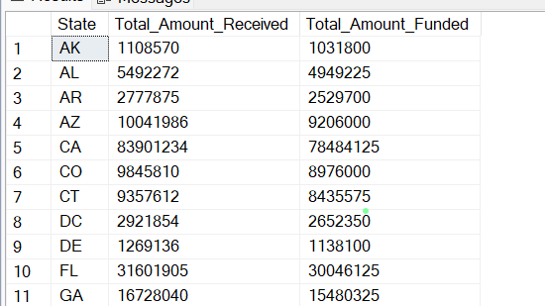

**Loan Term Analysis (Donut Chart):** To allow the client to understand the distribution of loans across various term lengths.

**Term**

select term as term,

sum(total_payment) as Total_Amount_Received,

Sum(loan_amount)as Total_Amount_Funded

from Bank_Loan_Data

group by term

order by term

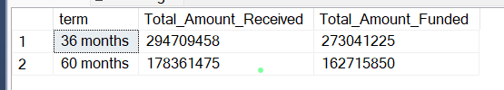

Employee Length

select emp_length as Emp_Length,

sum(total_payment) as Total_Amount_Received,

Sum(loan_amount)as Total_Amount_Funded

from Bank_Loan_Data

group by emp_length

order by emp_length

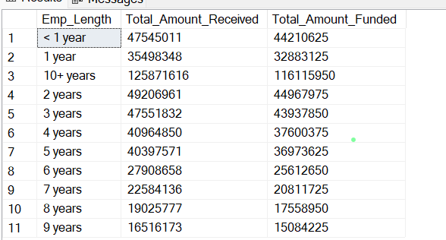

Loan Purpose Breakdown

select purpose as Purpose,

sum(total_payment) as Total_Amount_Received,

Sum(loan_amount)as Total_Amount_Funded

from Bank_Loan_Data

group by purpose

order by purpose

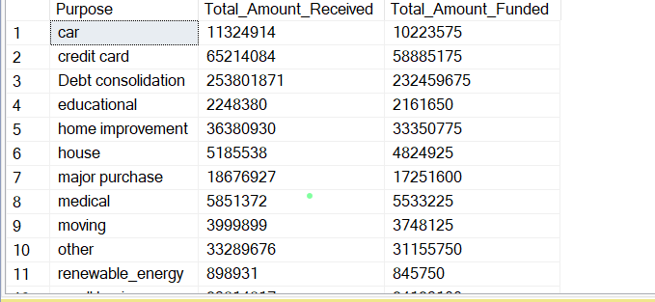

Home ownership

select home_ownership as Home_Ownership,

sum(total_payment) as Total_Amount_Received,

Sum(loan_amount)as Total_Amount_Funded

from Bank_Loan_Data

group by home_ownership

order by home_ownership

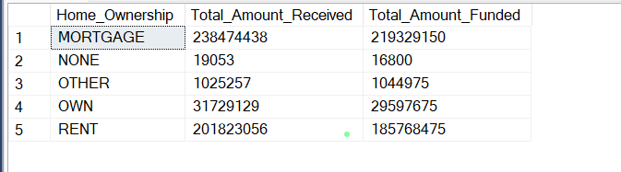

Calculate home ownership of Applicant for Total Amount recived and total amount funded for grade is A

SELECT

purpose AS PURPOSE,

COUNT(id) AS Total_Loan_Applications,

SUM(loan_amount) AS Total_Funded_Amount,

SUM(total_payment) AS Total_Amount_Received

FROM bank_loan_data

WHERE grade = 'A'

GROUP BY purpose

ORDER BY purpose

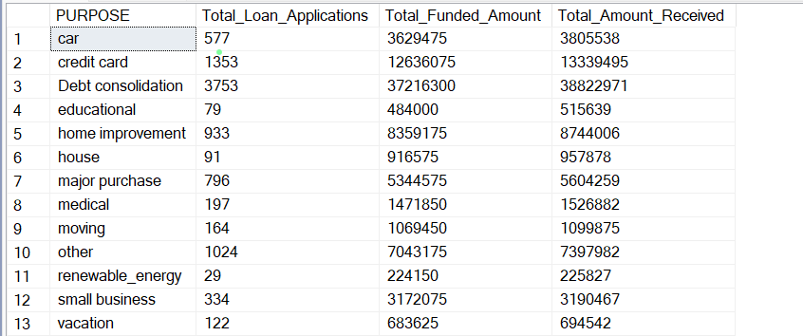

**POWER BI**

Import data through sql server and then check for column quality

Valid 100% means good to go we don’t have any null values

Incase of any null value in column it will show Empty %

Total Loan Applications = count(Bank_Loan_Data[id])

MTD Loan Applications = CALCULATE(TOTALMTD([Total Loan Applications],'Date Table'[Date]))

MOM Loan Applications = ([MTD Loan Applications]-[Previous month to date loan Apllications])/[Previous month to date loan Apllications]

MTD Total Funded Amount = CALCULATE([Total Funded Amount], DATESMTD(dateadd('Date Table'[Date],0,MONTH)))

PMTD Total Funded Amount = CALCULATE([Total Funded Amount],DATESMTD(dateadd('Date Table'[Date],-1,month)))

MOM TOtal Funded Amount = ([MTD Total Funded Amount]-[PMTD Total Funded Amount])/[PMTD Total Funded Amount]

PMTD Avg INtrest Rate = CALCULATE([Avgerage intrest rate],DATESMTD(dateadd('Date Table'[Date],-1,month)))